**EduTech Space Game**

**MASS EFFECT**

**-----By Maitree Rawat & Satyaki Goswami**

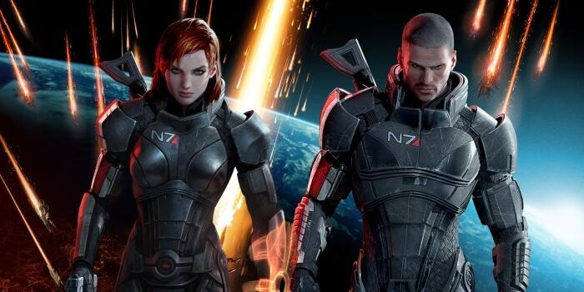

(Image : The female and male protagonist in the game)

Image Source : [www.hobbyconsolas.com](http://www.hobbyconsolas.com)

**THE IMPORTANCE OF SCI-FI GAMES**

Science Fiction, in a strange but beautiful way, has driven our scientific interests and curiosity throughout ages. Staying true to its literal meaning, sci-fi has helped us to visualize and imagine the universe with several novel approaches. Theoretical Physicist Michio

**(Image : Theoretical Physicist Michio Kaku (above) has stated in his book “Physics of the Impossible’ that ‘Flash Gordon was his childhood inspiration and it made him curious about the outer-space and technology)**

Kaku, in his book ‘Physics of the Impossible’ has stated that as a child, he was influenced by sci-fi shows like ‘Flash Gordon’- amazed by the concept of rocket ships, laser beams etc. Carl Sagan’s quest for the cosmos was inspired by Edgar Rice Burrough’s ‘John Carter of Mars’ novels. Not only literature, sci-fi from every field of the 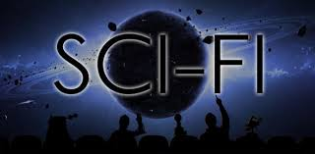media and pop-culture has helped people of science to envision futuristic concepts and theories, sparking a realistic preview of what the future might look like. The “Star Wars’ franchise questioned our point of view towards life, as we know it, by exploring the possibility of multiple extra-terrestrial civilizations and species living and existing as close or distant neighbours. Television shows like ‘Star Trek’ did the same before Star Wars. Eventually, sci-fi saw a new vector which could compete against the medium of literature and television media- Video Games.

**Image Source:** [**www.businessinsider.com.au**](http://www.businessinsider.com.au)

**Image Source :** [**http://www.stylinonline.com/scifi.html**](http://www.stylinonline.com/scifi.html)

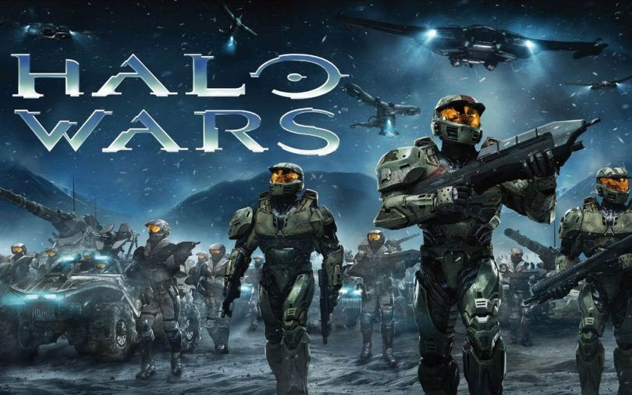

(Image : Halo Wars Scifi Game)

Since the last two decades of the twentieth century, video games have been an integral part of the pop-culture. Consequently, a large chunk of these games belong to the genre of science fiction. Games like ‘Halo’ and ‘No Man’s Sky’ are based on the concept of astrobiology and explore the possibilities of travelling great distances in space (among others). Video Games and other virtual simulations have been helping astronauts to prepare for deep space missions since quite some time. One of the game franchises that have constantly been under the spotlight for its scientific accuracies and futuristic vision is the ‘Mass Effect’ series.

Being one of the most popular gaming franchise, some people have deemed it to be “the most important science fiction gaming universe of our generation.”. Overkill? Maybe.Maybe not. But one can’t ignore the fact thatdespite other franchises claiming to have the same features in their games, there’s something that sets Mass Effect apart.

Image Source: <https://www.moregameslike.com/halo-wars/>

**THE MAKING OF MASS-EFFECT**

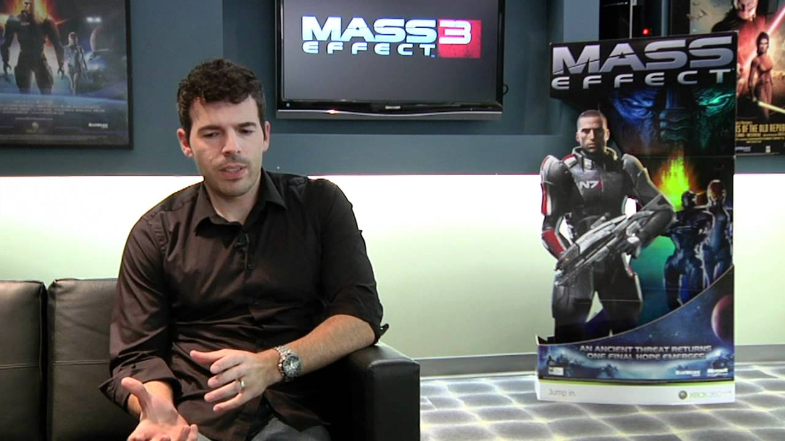

**Casey Hudson, Director of Mass Effect; Image Source: Youtube**

1)With a degree in mechanical engineering, Casey Hudson, the director of Mass Effect, always had a knack for art and music. After graduating, he heard of the ‘BioWare’ company was near his place. Although Hudson was interested in being a pilot or sticking to engineering in general, he realized his chances of applying the things [he liked to do] in the field of video games compared to any other. He joined BioWare as a 3D artist, concentrating on technical arts. Eventually, after gaining much experience, he was assigned as the project director. It is then when they decided to make a game heavily influenced by science fiction while being realistically as scientific as it could be.

Preproduction of Mass Effect began in early 2004. The game was meant to release on the Xbox 360 gaming console. More than 120 people were part of the development team. To lay the groundwork for the game, ‘Unreal Engine 3’ was used. Unreal Engine is a software which acts as a platform to develop and build games. Mass Effect eventually became BioWare’s largest project, in terms of programming, at that time- they had to spend a lot of time in order to develop digital components for virtual space exploration and combat. Around a year was spent in was spent in conceiving the whole game while the development process took almost four years. The game was heavily influenced by space operas like Star Wars and Star Trek.

The original trilogy of the franchise takes place in the distant future, in a fictional Milky Way galaxy, which is now home to various alien species. Technological as well as scientific aspects are far more advanced due to this unity among various sentient beings who regularly exchange knowledge. Most of the races base their technological prowess to that of an ancient civilization- The Protheans. Most of these technological advancements are due to a substance called ‘Element Zero’ which was left by the Protheans. A form of advanced technology itself, Element Zero can alter the mass of anything near it, hence the title. Technologies like force-fields, faster-than-light travel etc. are the fruits of this mass altering tech. 2)Some of the scientific aspects of the game involve concepts which are being rigorously worked on in real life. Let’s take a look:

1. Invisibility Cloak:

How far away are we from actually seeing a technology that makes us invisible for real (not camouflaging)? In a few decades, maybe microwave radiations can help us. Microwave radiation can go around an object, wrap around, and reform at the other end as if the object is not there at all. As a theoretical concept, one can imagine an object being inside a cylindrical structure, around which, light shall wrap and reform at the other end. Militaries in many nations are funding this kind of research as it’d give immense advantages in combat.

1. Telekinesis

The ability to move objects with the power of mind, without actually moving them. With the help of EEG and MRI scans, we are now beginning to decode the basic operating system of the brain. In future, we will have superconductors based in different objects. The human mind will activate a computer through these which in turn will move objects around us at our will.

**EDUCATIONAL VALUES ARE THERE ANY?**

The game not just opens the opportunity of thinking beyond the galaxies but the possibility of life beyond earth. The game revolves around Commander Shepard, whose mission is to save the galaxy from the race of powerful mechanical beings known as the Reapers and agents. A Reaper is essentially “billions of organic minds, uploaded and conjoined with immortal machine bodies”.

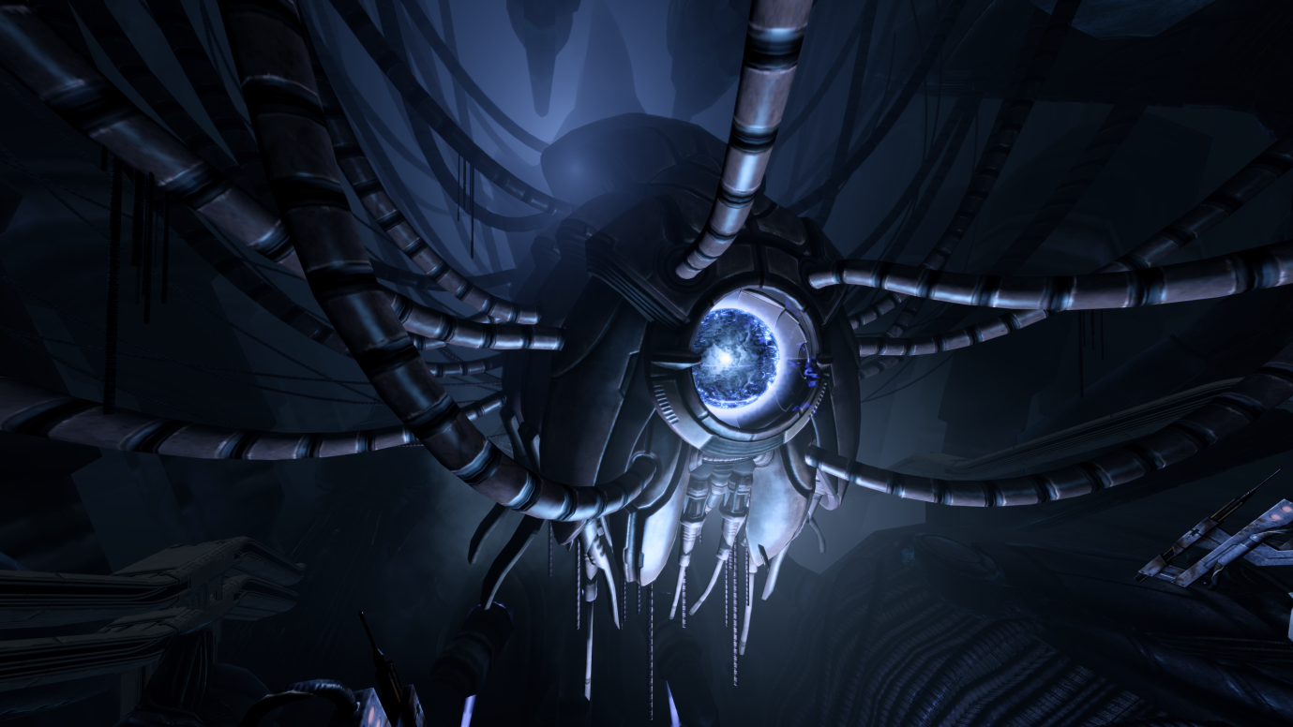

(Source : Mass Effect Wiki)

It also encourages children to think of the extra galactic dark-space. Extra galactic mostly used in Fictions and Science Series generally refers for alien species, organisations and sometimes objects believed to have either originated outside or travelled beyond the boundaries of galaxy.

And then another question arises here , can we travel beyond the boundaries of galaxy or maybe travelling between different universes is that possible?

This may further makes the players think here about the existence of multi-universe or parallel universe. The second game takes us two years later, and sees Shepard battling the Collectors, an alien race abducting entire human colonies in a plan to help the Reapers return to the Milky Way. The Collectors if you’d ever look for it in the official Mass Effect website you’ll find that they are an enigmatic race that live Beyond the Omega 4 Relay , a mass Relay within the same system as Omega, in the Terminus System.

Omega 4 Relay Galaxy?

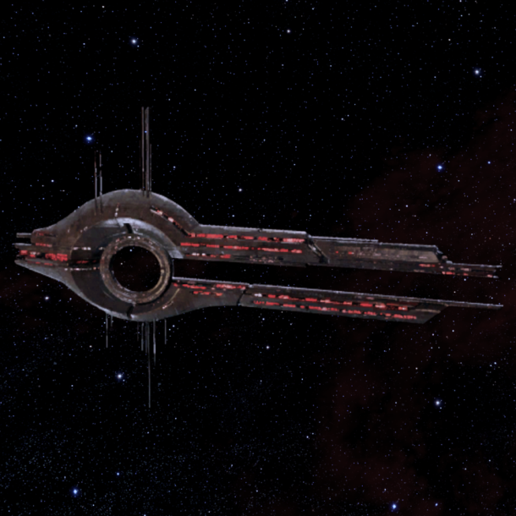Omega 4 relay is surrounded by hazard beacons and automated warnings. Over the last thousand years, many ships have attempted to pass through it, but none have returned. The only ones to pass freely back and forth through the relay are the mysterious Collectors.

There are many theories why ships never returns from Omega 4 , Some says there is a black hole at the far end ; others believe that there is some form of earthly paradise.

Things like Omega 4 relay , Collectors and Reapers doesn’t tells us the truth about the space , the galaxy where we live and the universe which we are a part of but it does opens the minds of the Readers/ Gamers to think beyond whatever we learnt during the High School. Omega 4 Relay may never exist but it will tend the gamer to think about the existence of Black Hole the hot potato. The reader may end up reading papers about the Black Hole ,the theory and arguments against the parallel universe and the existence of species in other galaxies.

Image Source: Mass Effect Wikia

PARENTAL REVIEWS ALERT

It won’t be surprising if you won’t find any obscene character and/or “inappropriate for minors” content. The in-game violence is on par with most shootering, but isn't gratuitous; players will shoot with pistols, shotguns, and rifles, and use grenades. But the focus of this game is on the interactive storyline where players decide the dialogue of their characters, leading to moral decisions about whether you traverse the galaxy as a diplomatic hero or a renegade willing to bend the laws, and these decisions have consequences.



Snippet From : Common Sense Media.org



**RECOGNITION AND AWARDS**

Mass Effect was a trilogy by Canadian Company Bioware. All of the first three major instalments of the Mass Effect series have been met with commercial success as well as universal acclaim. The series is highly regarded for its narrative, character development, voice acting, universe, and emphasis on player choice affecting the experience. Two weeks after the game was released, Mass Effect 2 shipped two million copies to retailers. The game sold over 500,000 copies in the month of release, despite being released at the end of the month. Before the release of the third game, the series sold a total of 7 million copies worldwide.

Mass Effect 3 sold over 800,000 copies in its first 24 hours, and its opening month sales were twice that of its predecessor's, selling over 900,000 copies on the Xbox 360 version, outselling the PlayStation 3 version 4 to 1 and bringing in over $200 million in revenue.

As of July 5, 2014, the Mass Effect series has sold a total of 14 million units.

The Mass Effect series, particularly the second game, has received universal acclaim. [Colin Moriarty](https://en.wikipedia.org/wiki/Colin_Moriarty) stated that "the Mass Effect series is one of the defining video game franchises of [[the seventh] generation](https://en.wikipedia.org/wiki/History_of_video_game_consoles_(seventh_generation))." [Games Radar](https://en.wikipedia.org/wiki/GamesRadar) called Mass Effect the best new franchise of the (then seventh) generation, saying "The galaxy was so well-constructed that it felt like a decades-old franchise and represented a high-water mark for video games as a story-telling medium."

[GN](https://en.wikipedia.org/wiki/IGN) rated the Mass Effect trilogy the best Xbox 360 game(s) out of a list of 25, despite being multiplatform.

Mass Effect 2 is widely considered to be one of [the greatest games of all time](https://en.wikipedia.org/wiki/List_of_video_games_considered_the_best). It garnered numerous game of the year awards and is critically the most successful game in the series. It received over 70 perfect review scores.

While Mass Effect 3 also garnered critical acclaim, controversy surrounded its release due to the public's reaction and refusal to accept the game's (and the trilogy's) ending. This eventually led to BioWare releasing an "extended cut" patch to the ending of Mass Effect 3 which would expand upon, but not replace it.

The fourth instalment, Mass Effect: Andromeda received mixed critical reception and was considered not up to par with the original trilogy. Apart from the Game it also sold its novels, comics and movies developed.

Source : Mass – effect Wikipedia

**CONCLUSION**

In conclusion, one might repeat or rephrase the question asked at the beginning of this article- What sets Mass Effect apart from its counterparts? The reason is simple and mesmerising.

Mass Effect is probably the first postmodern era video game that makes us question ourselves; a trait which we wouldn’t expect from a video game in general. It confronts the universe as it is; godless and indifferent. It shoves our entitlement to the gutters and makes us know that we are as special as the cattle; it makes us realise that in a cosmic backdrop, the smartest man on the planet is no better than the smartest termite. It interweaves the questions about the value of existence amidst the game-play. It tries to justify survival, not just intelligence, while asking what it means to exist. Whether you’re liberal, a conservative, a religious person or an atheist, Mass Effect demands you to ‘recontextualise’ your word.

**References**

*1) Casey Hudson Interview- Mass Effect’s Feedback; Game Informer*

*2) Science Of Mass Effect with Dr Michio Kaku; Youtube*

*3) Common-Sense Media Mass Effect*

*4) Mass Effect Bioware Official Website :* [*www.masseffect.bioware.com*](http://www.masseffect.bioware.com)

*5) Wikipedia*